# Answers to Questions from P2.1

Name: Harry

Student ID: 103517299

## Is the font type in helloworld2.html similar to helloworld.html (you created in the first week)? Ans: No, the fonts are different.

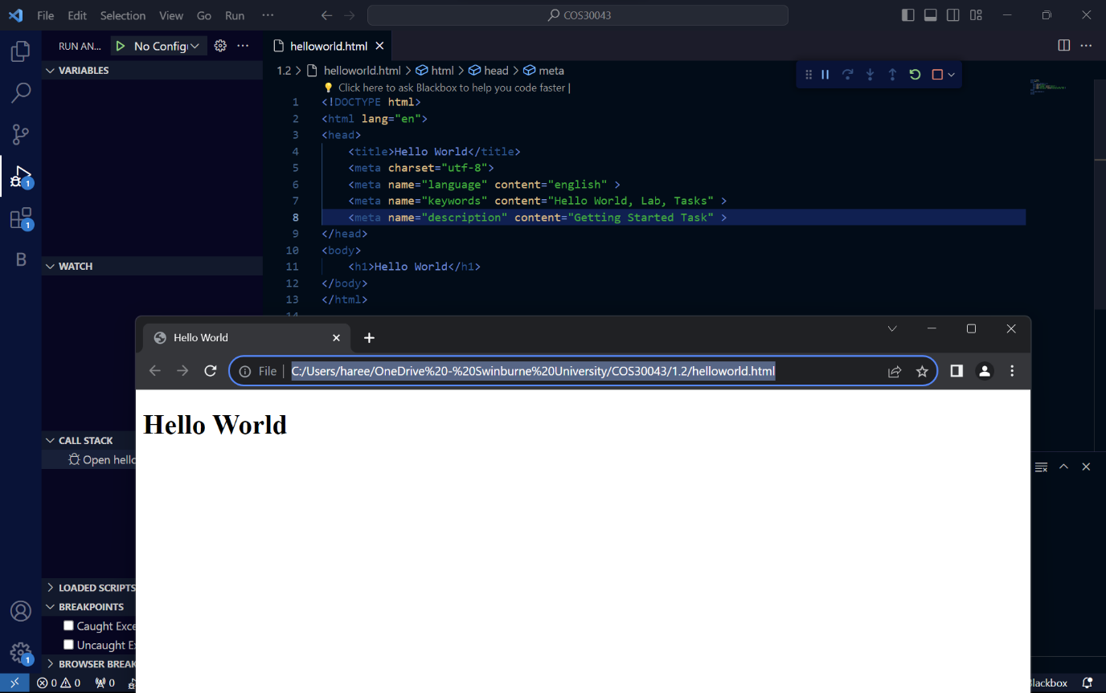

Fig:first week helloworld.html

Fig: second week helloworld2.html

## What happens if you remove <div class="container"></div>?

removing the <div class="container"> significantly altered the layout and appearance of the content 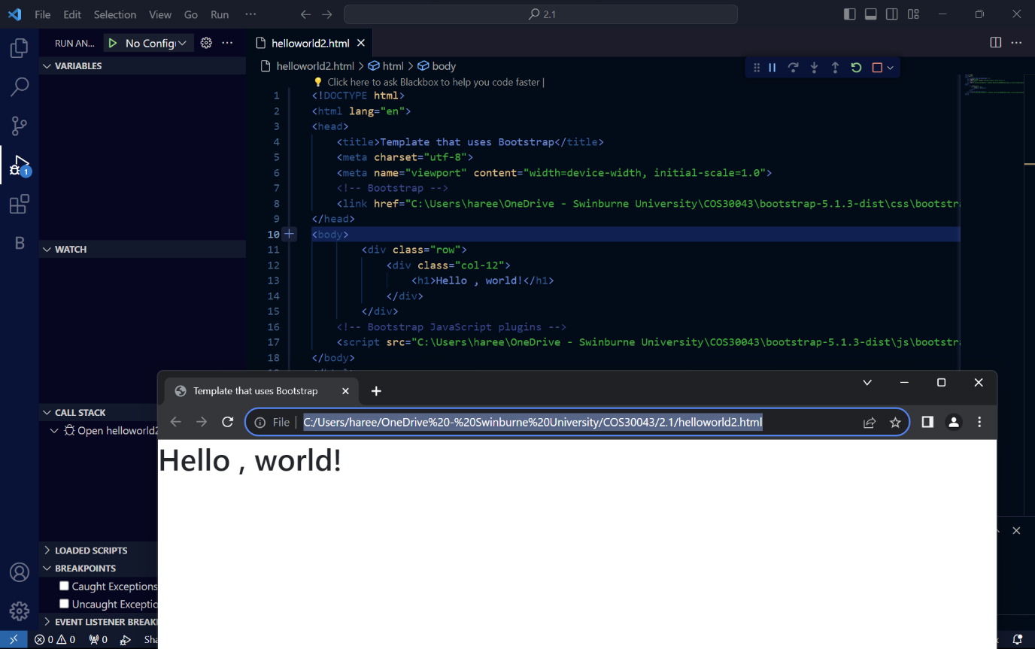

## What is the purpose of <div class="container"></div>?

The `<div class="container">` in Bootstrap is used to provide a responsive fixed-width container for content, ensuring proper alignment and padding while maintaining consistency across different screen sizes.